OUTPUT

Challenge 1: Find Longest Student Name
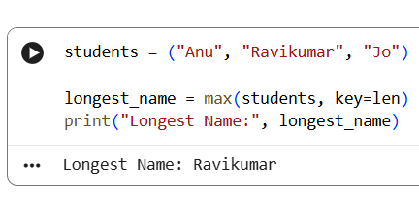

Challenge 2: Join Subjects into Single String
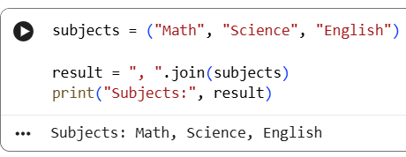

Challenge 3: Reverse Each Student Name
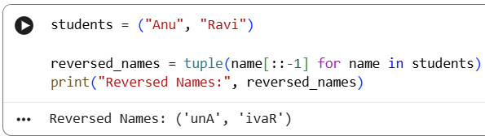

Challenge 4: Count Vowels in Each Name
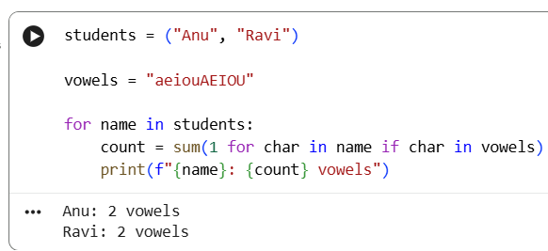
Challenge 5: Convert Tuple to Uppercase String
